AEM Author Portfolio Website

## Introduction

This documentation provides a detailed overview of the implementation of an AEM author portfolio website. The website is built as part of an assignment to showcase an author's work, awards, and social media presence using various AEM components and templates.

1. **Page Structure and Components**

# Header

Implemented using the OOTB Header component.

Includes navigation links for Books, About Me, Contact Me, and Homepage.

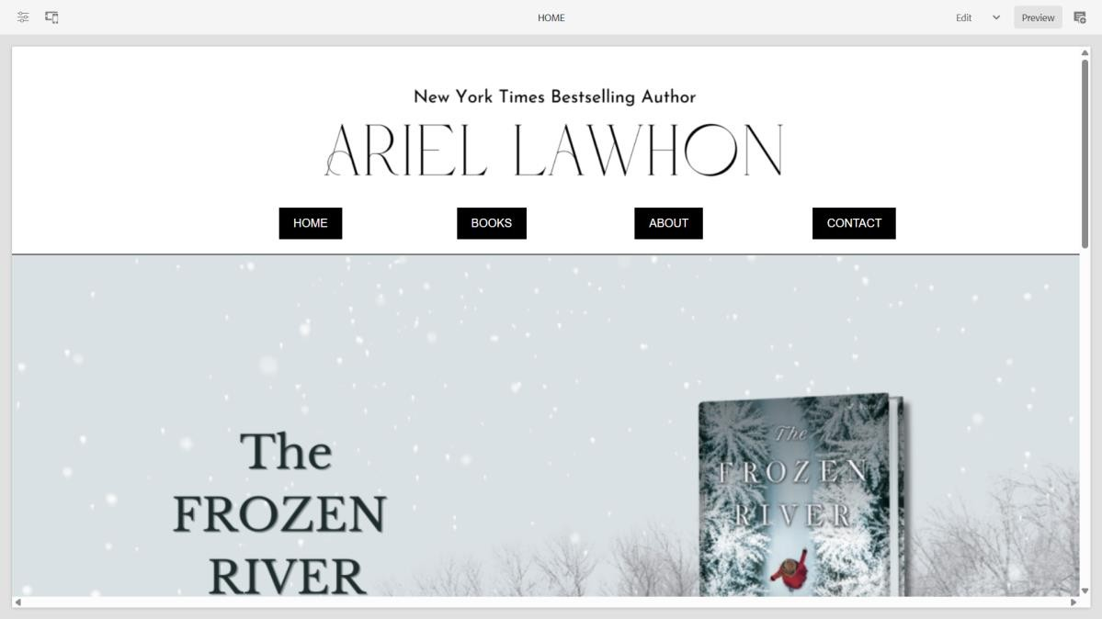

# Footer

### Home Page Template:

Built using the OOTB Content Page template.

Features a teaser component displaying an award ceremony with image, title, description, and CTA.

Additional components: Text, Image, Title.

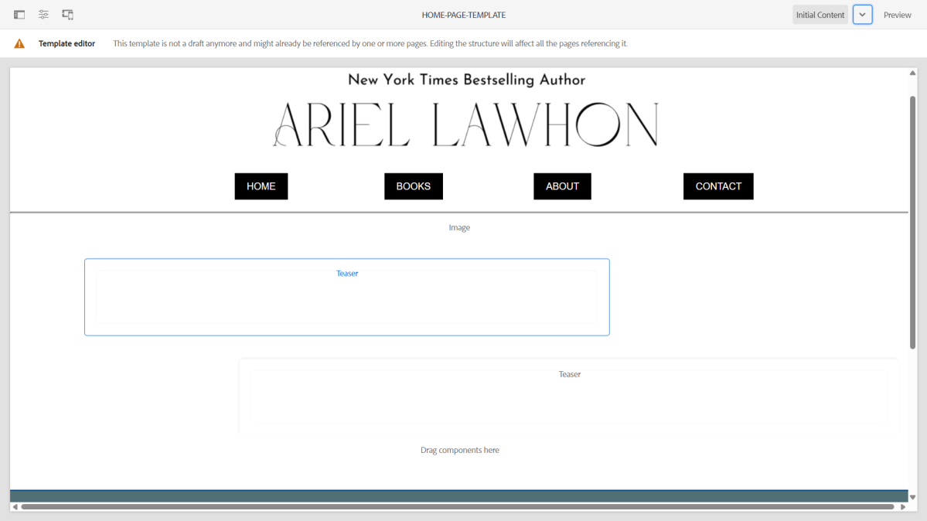

### Home Page:

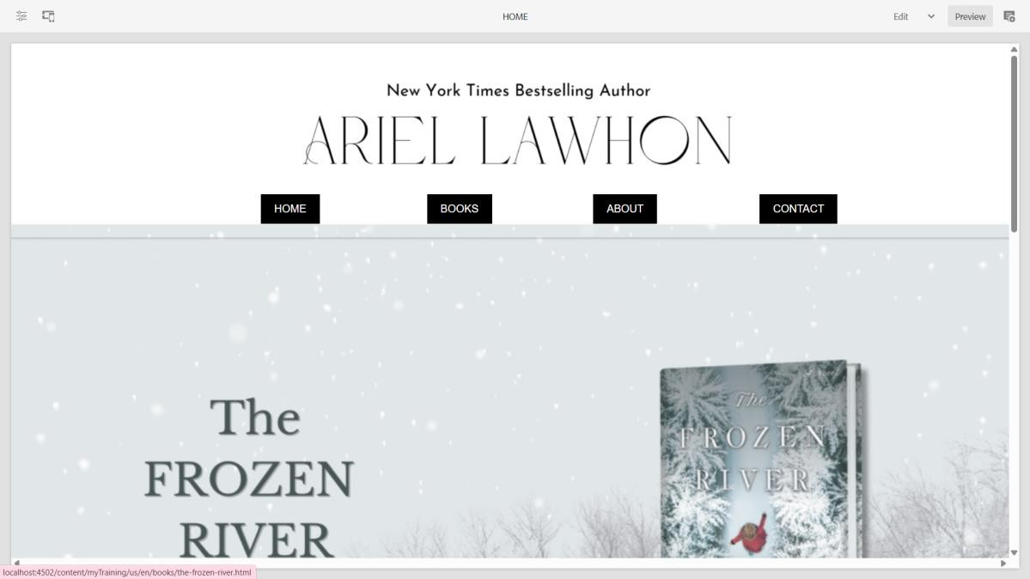

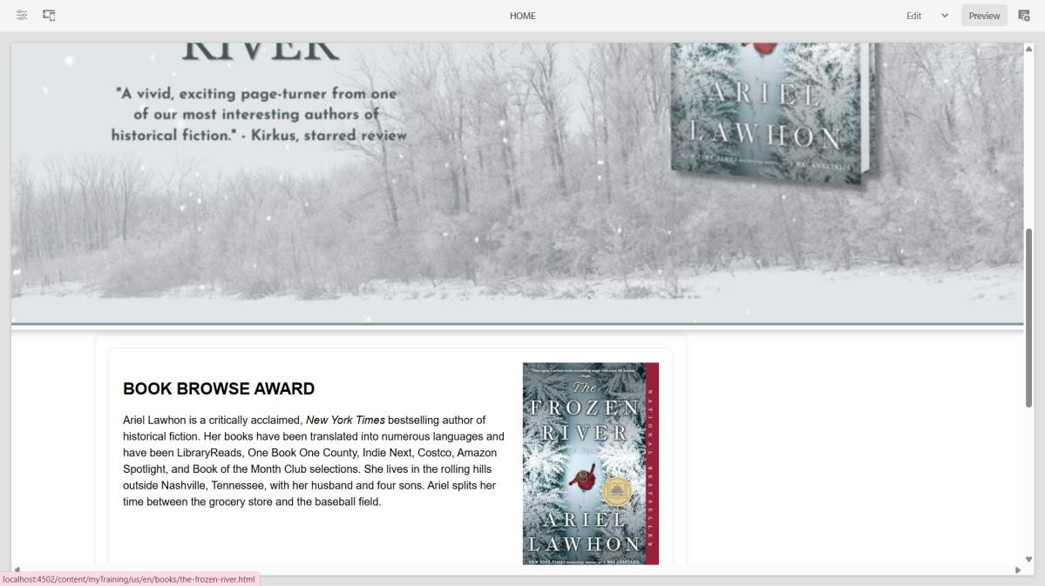

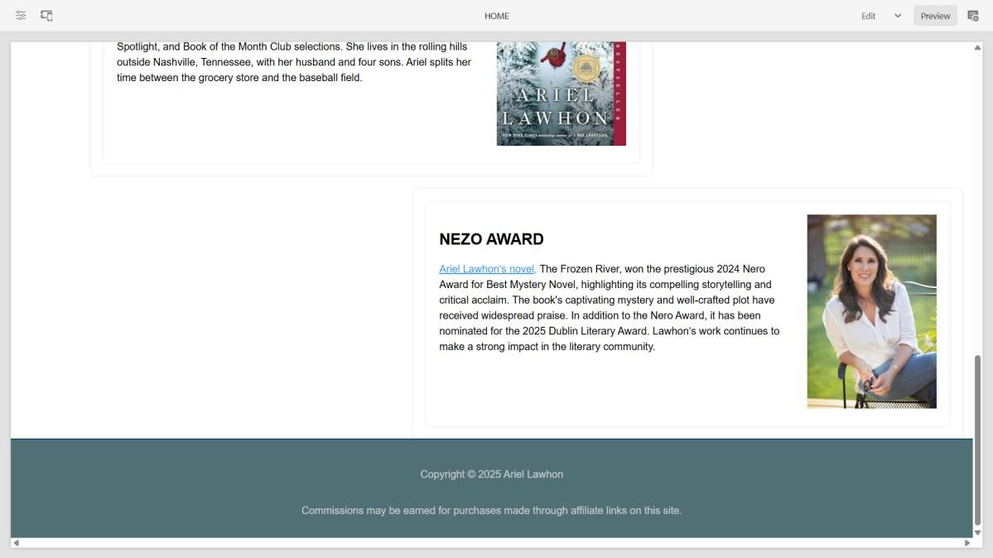

**Books Page**

Created using a custom Book Page template.

A custom Book Component fetches book data from pages authored under /content/books. Book pages include Title, Description, and Image components, ensuring uniqueness across all entries.

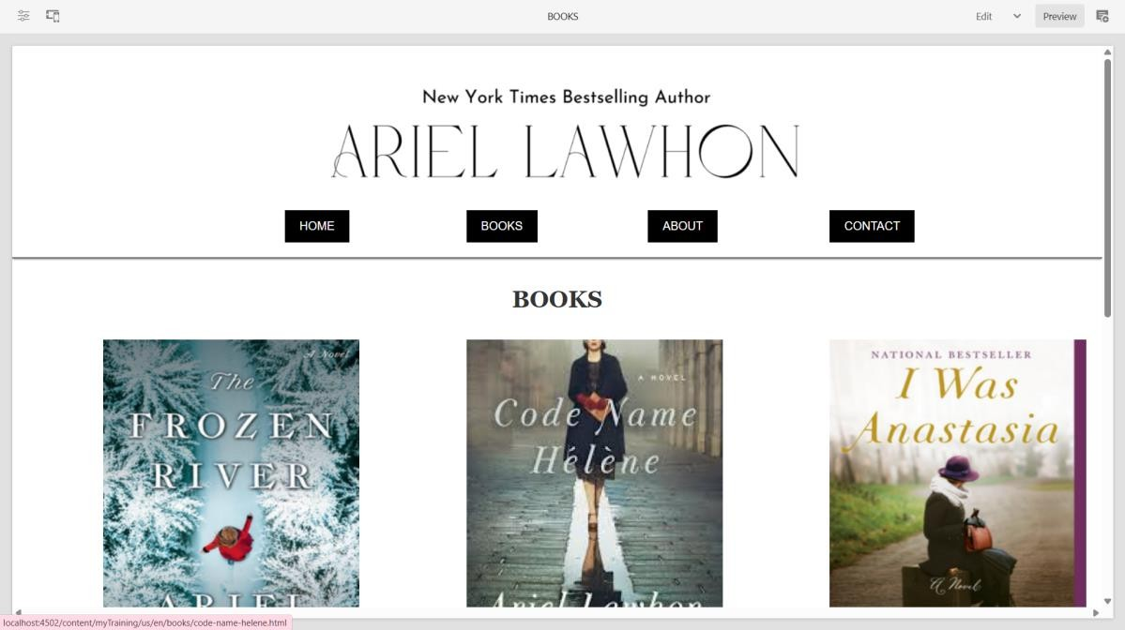

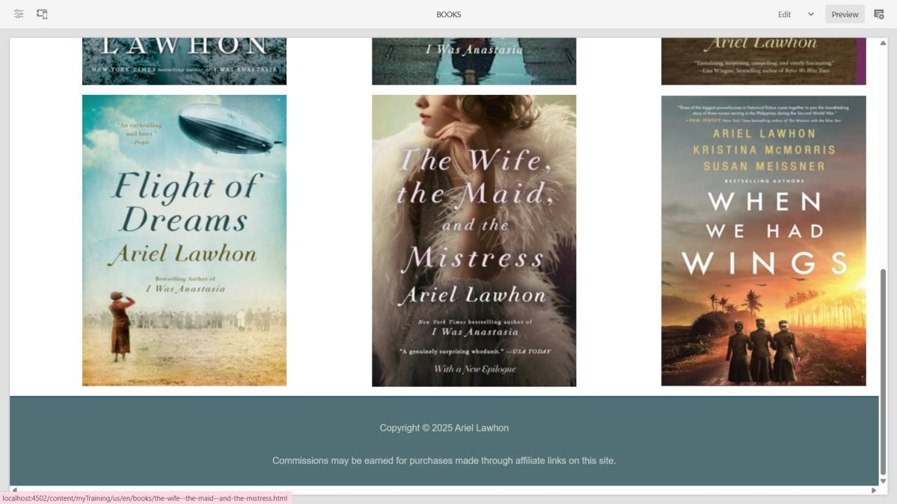

### About Me Page

Uses a custom Author Component to display author information.

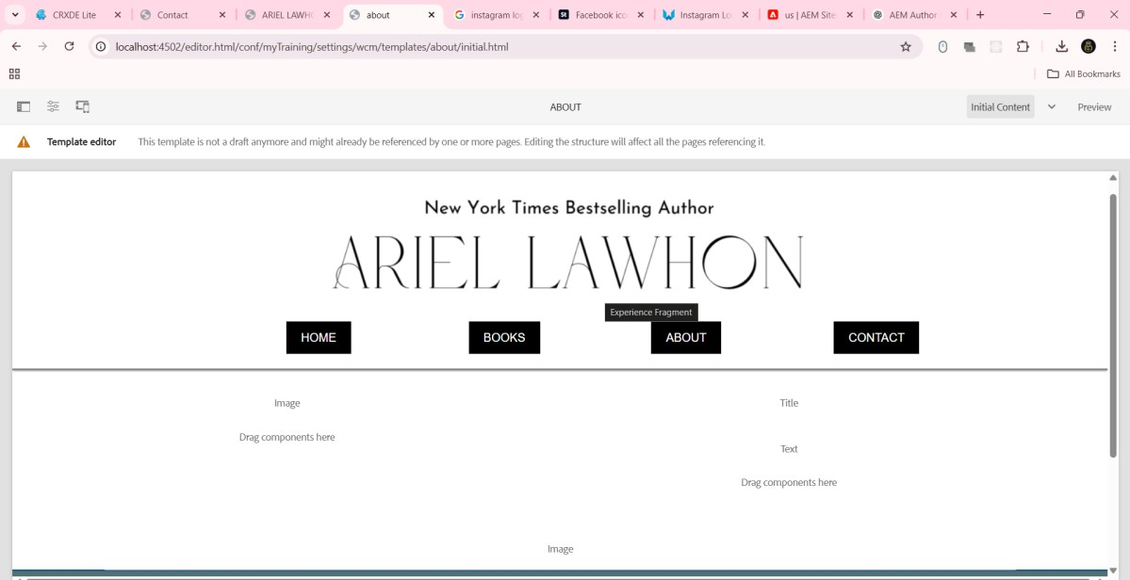

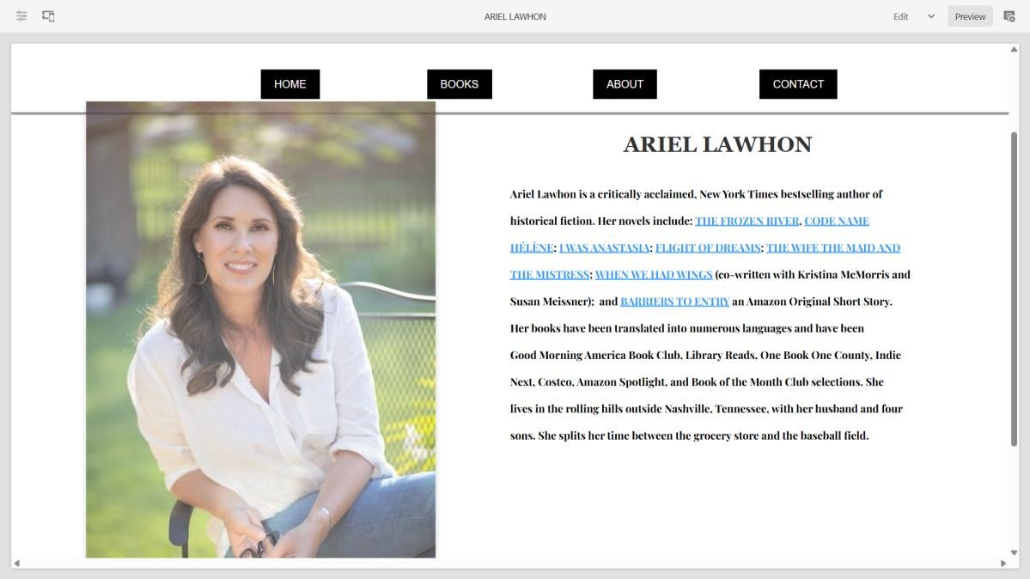

### Contact Me Page

Uses text or teaser components for displaying contact details and social media links.

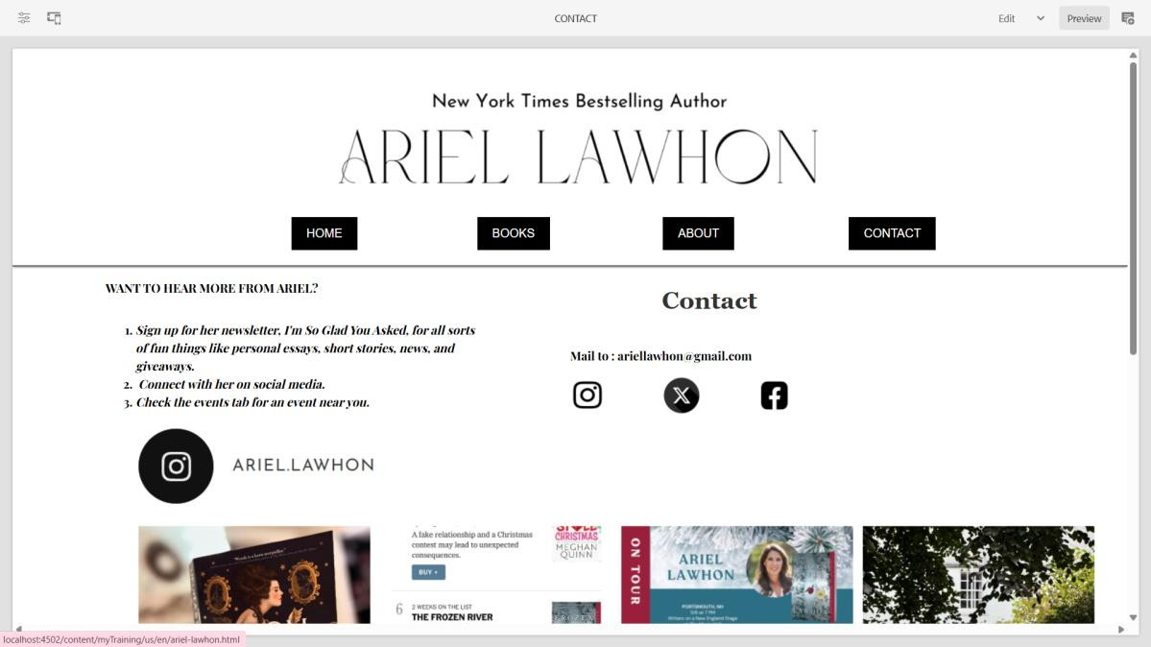

## 8. Conclusion

The AEM author portfolio website has been successfully implemented as per the requirements. The use of OOTB components, along with custom implementation for the book component, ensures efficient content management and dynamic rendering of

authored content. The project is now ready for deployment and further enhancements if required.